Amino Acid Properties in Observed Structural Motifs

Structural Analysis of Scorpion Toxin Protein (PDB: 2I61)
Inna Kucherova

Part I: Structure Quality & Metadata

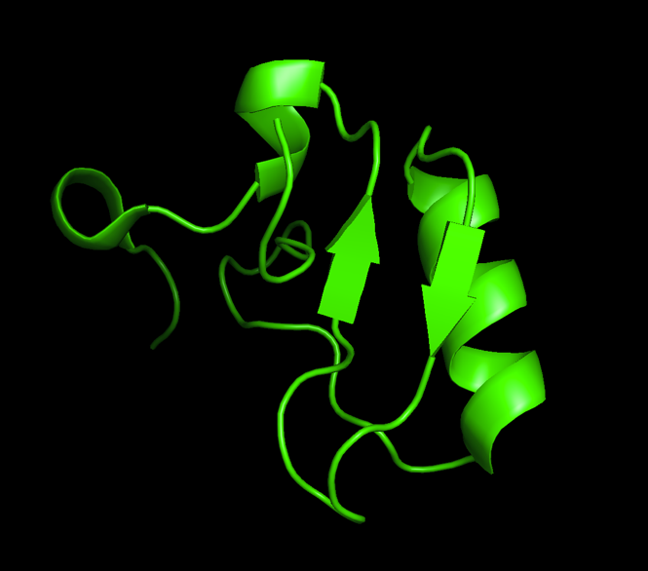
PDB Information
- PDB ID: 2I61
- Title: Crystal structure of the scorpion toxin LqhIT2
- Organism: Leiurus quinquestriatus (Deathstalker scorpion)
- Year: 2006
- Methodological Quality
- PDB ID: 2I61
- Resolution: 1.20 Å (Atomic Resolution)
- R-values:
  - R-Value Work: 0.096 (9.6%)
  - R-Value Free: 0.120 (12.0%)
The structure of toxin was determined at a high resolution of 1.20 Å, which allows clear visualization of individual atoms and side-chain orientations. R-value 0.120 is considered significantly low (values <0.20 are regarded as very good) and demonstrate that the model fits the experimental diffraction data with near-perfect accuracy and minimal overfitting.
- B-Factor Analysis
B-factor analysis reveals that PDB 2I61 is a highly rigid structure, consistent with its function as a stable toxin.
- The Rigid Core: Quantitative scaling shows that the majority of the protein, specifically the cystine-stabilized alpha-helix and beta-sheet core, exhibits extremely low thermal motion (deep blue).
- The Flexible Loop: Rescaling the visualization identified a single region of relative flexibility: the solvent-exposed loop containing Asp-49 and Asp-50. This region likely acts as a flexible hinge to facilitate target recognition, while the rest of the scaffold remains a "molecular rock."
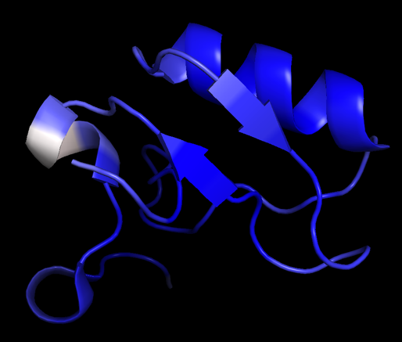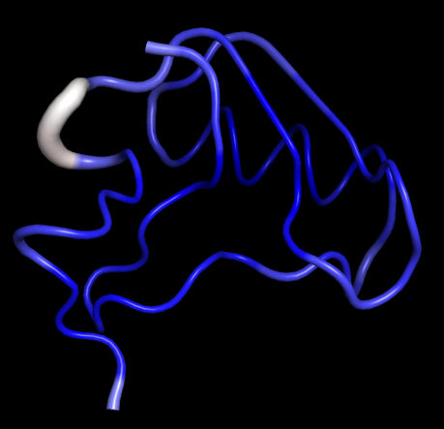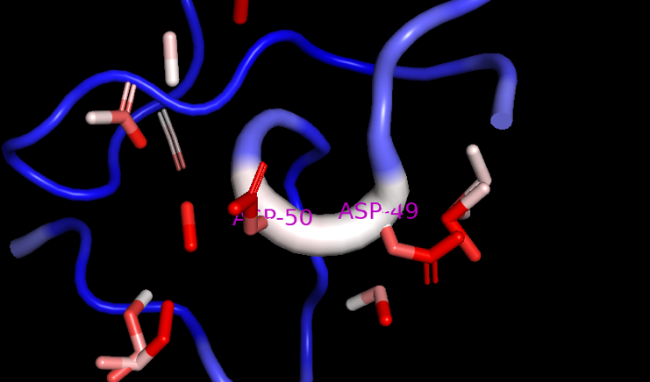

Part II: The Hierarchy of Structure
    - Hydrophobic Core vs. Solvent-Accessible Surface
The overall topology consists of an alpha-helix aligned parallel to a double-stranded anti-parallel beta-sheet. This arrangement is referred to as the alpha-beta motif.
The structure shows a clear separation of amino acids caused by the hydrophobic effect, which matches the "Core-globule" stabilization described by Karbat et al. (2007).
- The hydrophobic core is the inner part of the structure, where non-polar amino acids like Trp-38, Leu-47, and Ile-16 are packed closely together.
Trp-38 is the most critical core residue. It is a highly conserved aromatic ring located centrally within the beta-sheet.
Leu-47 projects inward from the beta-strand to interact with and stabilize the adjacent helix.
Ile-16 located near the N-terminus of the helix, packs into the core to stabilize the initial segment of the secondary structure.
- The hydrophilic surface is the outer part of the structure, made up of polar and charged amino acids like Tyr-28, Cys-10 and Gly-9.
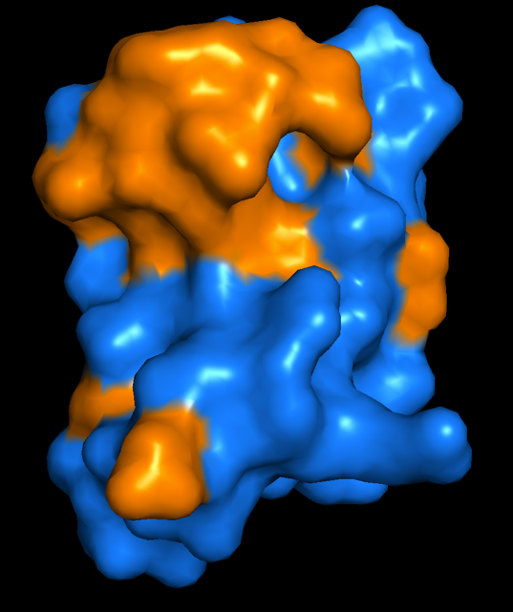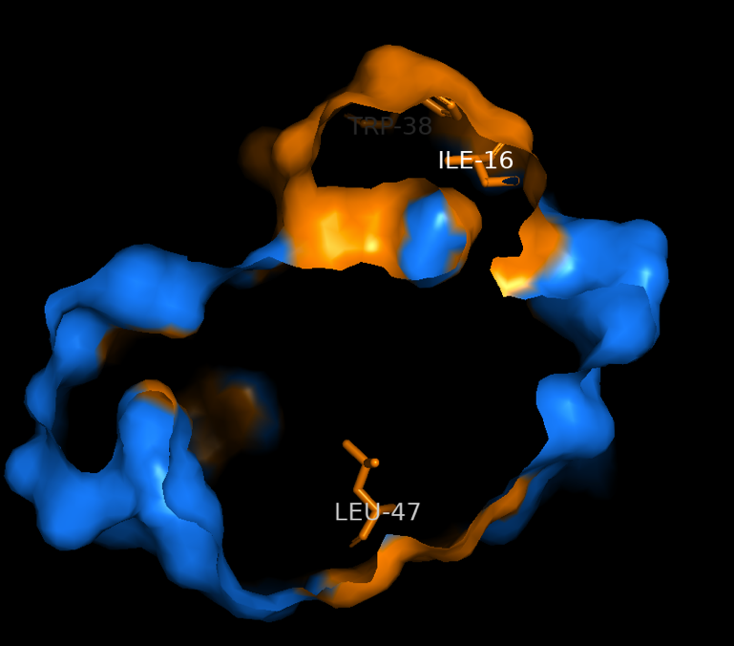
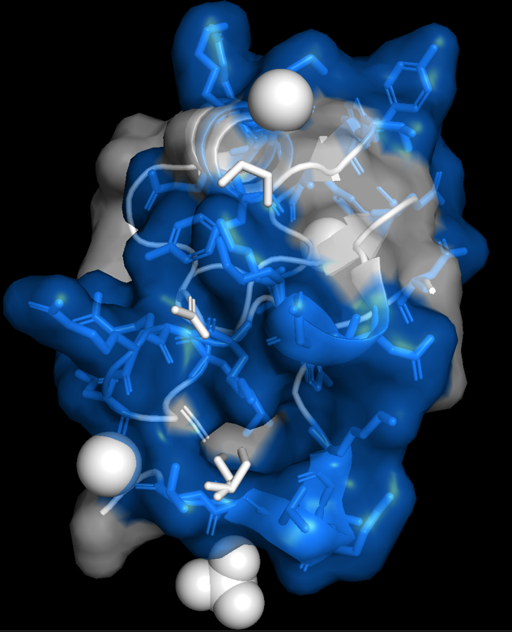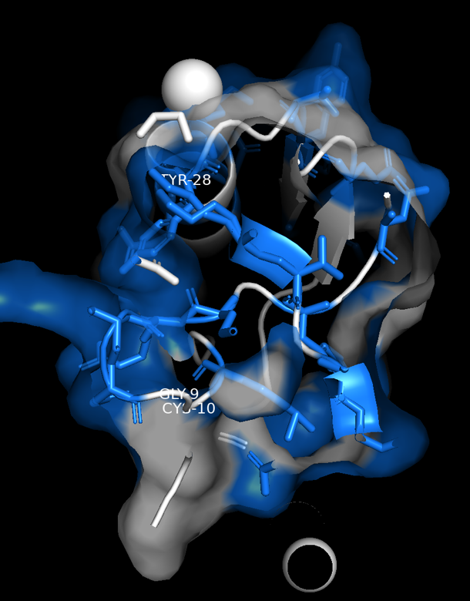

Part III: Analysis of Secondary Structural Motifs
  - The Amphipathic -Helix (Residues 19–29)
The alpha-helix shows a clear amphipathic pattern that repeats every 3 to 4 residues. Hydrophobic residues like Gly-20 and Ala-27 are found on one side of the helix, facing the protein core. On the other side, hydrophilic residues such as Glu-24, Lys-26, and Tyr-28 face outward into the solvent. This arrangement allows the helix to sit on the protein surface, linking the hydrophobic interior to the surrounding water.
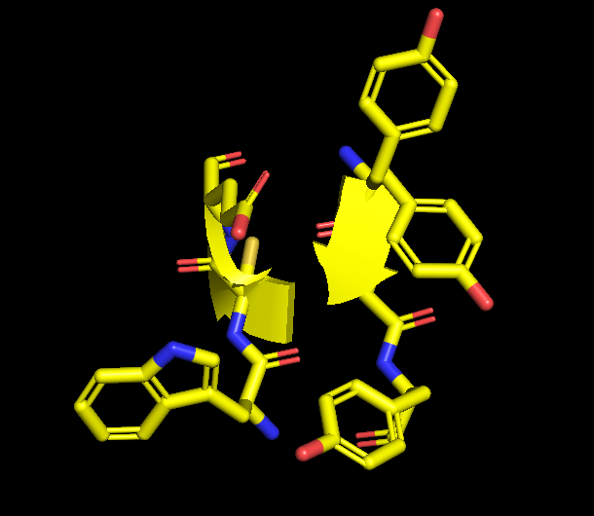
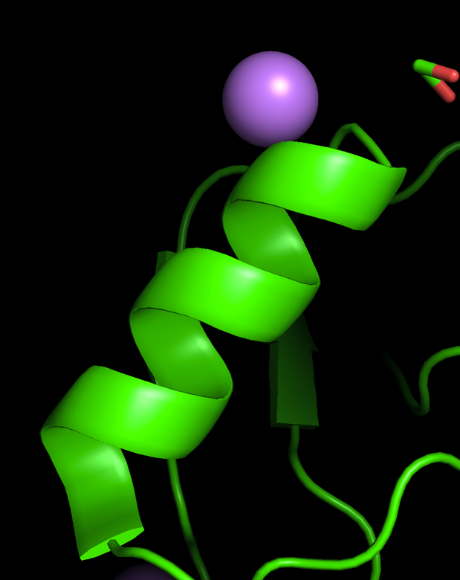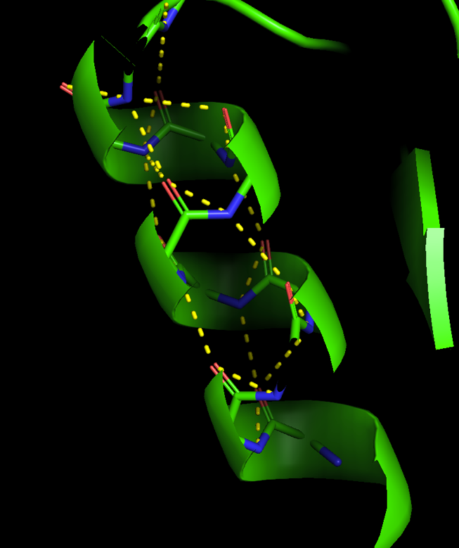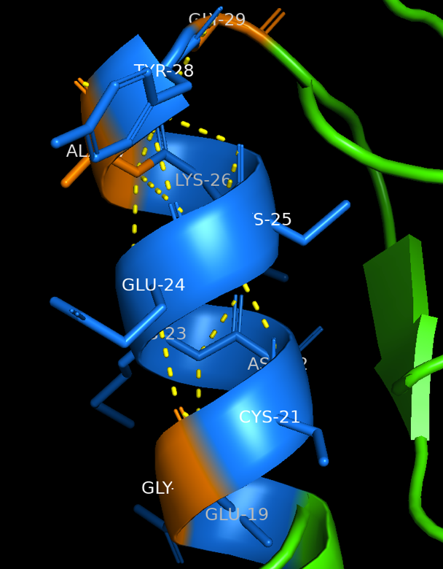
  - The Anti-Parallel -Sheet
Looking at the direction of the backbone shows that the sheet is anti-parallel, with one strand running in the opposite direction to its neighbor.

- Zipper packing describes how the side chains at the interface between strands fit together closely. Hydrophobic residues from each strand alternate in an in-out pattern, fitting together like a zipper to keep out water and stabilize the CS-alpha-beta motif.

Part IV: The Structural "Rebels" (Glycine & Proline)
  - Glycine-17: The "Helix Starter"
A close look at the angles in the protein backbone shows that Gly-17 is unusual compared to the others.
- Gly-17 has a positive Phi angle of +153.2°.
- On the Ramachandran plot, this shape shows up in the "disallowed" bottom-right area for standard amino acids because the atoms are too close together and bump into each other.
- Since glycine does not have a side chain, it avoids these bumps. This flexibility lets Gly-17 act as a starting point, making the sharp twist in the backbone needed to begin the alpha helix.
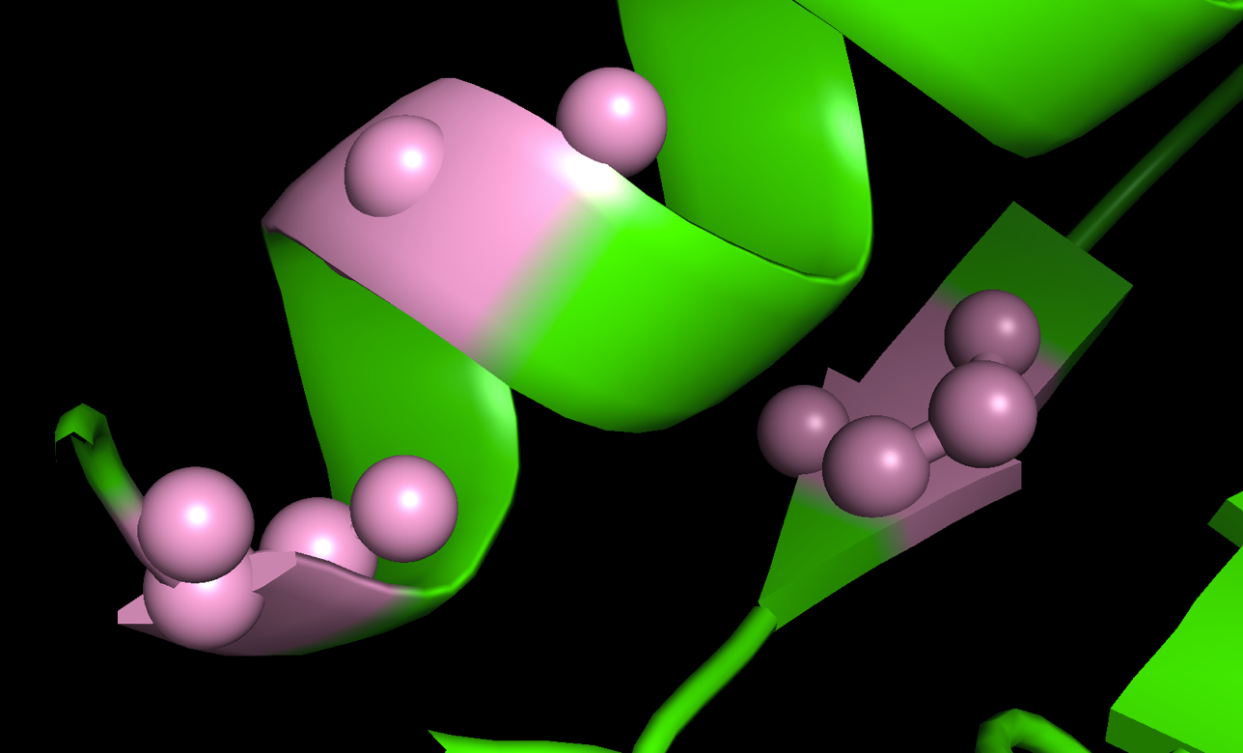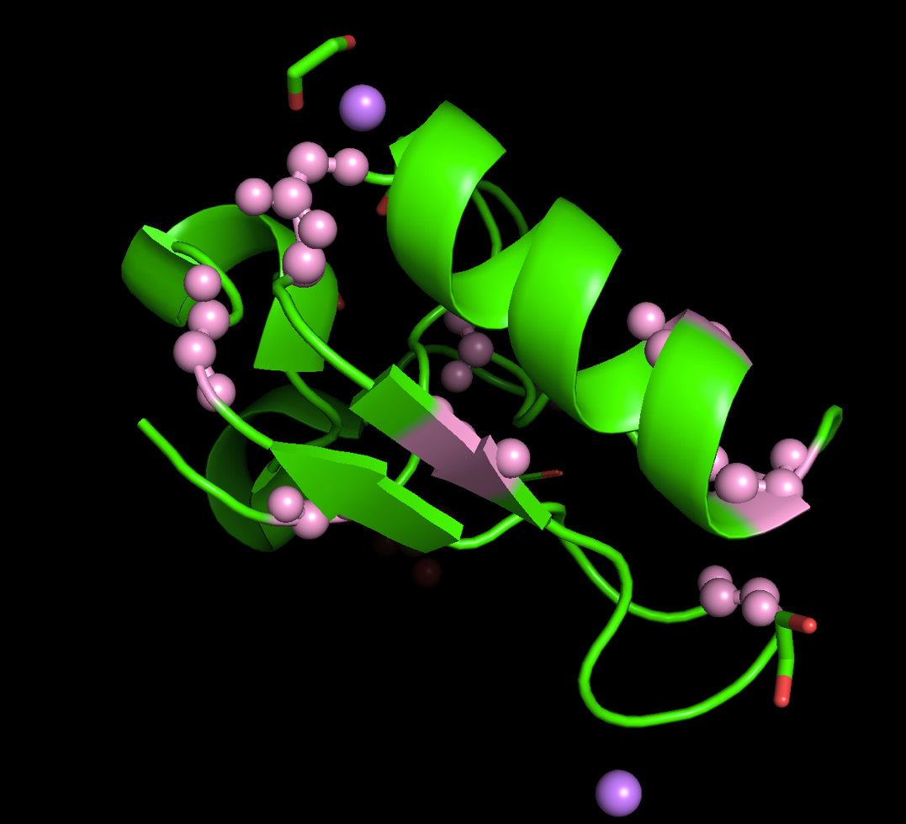
  - Proline: The "Helix Breaker"
A Proline amino acid was found to disturb the nearby protein structure.
The side part of Proline forms a ring that attaches tightly to the main part of the protein chain.
- Consequences:
1. Hydrogen Bond Disruption: The nitrogen does not have a hydrogen to share, so it cannot help form the usual bonds in the helix structure.
2. Steric Locking: The stiff ring fixes the angle of the chain, creating a permanent bend.
- Result: This amino acid ends the regular structure and acts like a stiff block that changes the direction of the protein chain.
